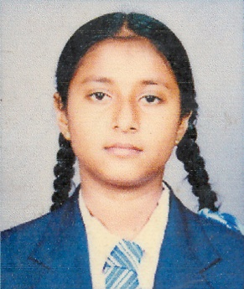

**CURRICULUM VITAE**

**PERSONAL PROFILE**

* Full Name : Warnakulasuriya Chansi Udara Sammani Fernando
* Name with Initials : W.C.U.S. Fernando
* Date of Birth : 1994.11.12
* Address : No. 28/A, Sagaragama, Nattandiya.
* N.I.C. No. : 948171155V
* Nationality : Sri Lanka
* Gender : Female
* School Attended : Lourdes College, Nattandiya
* Contact No. : 0770664733/ 0327900053
* Civil Status : Single
* Email Address : sammaniudara81@gmail.com

**EDUCATIONAL QUALIFICATIONS**

**Passed G.C.E. O/L Examination 2010 – Index No: 62683713**

**Subject Grade**

* Mathematics A
* Bus. & Acct. A
* Religion A
* English B
* Sinhala C
* History C
* Science C
* Arts C
* I.T. S

**Passed G.C.E. A/L Examination 2013 – Index No: 8646821**

**Subject Grade**

* Economics B
* Accounting C
* Business Studies C
* English S

**PROFESSIONAL QUALIFICATION**

* Successfully completed six months job skill development programme in

Bank of Ceylon – Marawila branch from October 2014 to April 2015.

**OTHER QUALIFICATIONS**

* Successfully Completed Certificate Course in English at St. Anthony's Institute of Higher Studies, Chilaw.

**EXTRA CURRICULAR ACTIVITIES**

* I was a school Prefect in Lourdes College from 2008 to 2013.
* I was the Leader in Lourdes College Girls Band from 2010 to 2013.

**NON RELATED REFEREES**

* Mr. M.A.D.L. Fernando

Customer Relationship Assistant

Assetline Leasing Company Limited

Chilaw

032-4658546 / 077-8976417

* Miss A.D. Dassanayake

Manager

Bank of Ceylon

Marawila

032-2252675 / 077-3500617

I do hereby certify that the above mentioned particulars are true and accurate to the best of my knowledge.

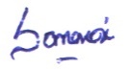

09.10.2015

.................................. .....................................

Date Signature